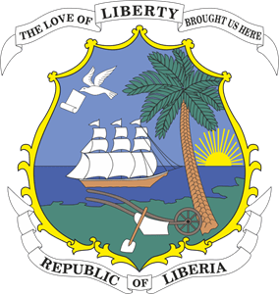
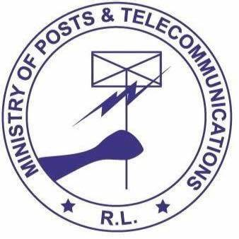


Republic of Liberia

Ministry of Posts and Telecommunications

Western African Regional Digital Integration Project – Series of Projects 2 Liberia (WARDIP SOP2-Liberia)

Project ID: P500628

Terms of Reference
For
Recruitment to conduct Feasibility Study and Legalization of the Liberia Research and Education Network (LRREN):

The Government of Liberia (GoL) has received financing from the World Bank for the preparation of the West Africa Regional Digital Integration Project - Series of Projects 2 Liberia (WARDIP SOP2-Liberia). This project, which will be implemented at the national level, seeks to facilitate increased broadband access and usage in preparation for regional digital markets integration in West Africa.

WARDIP SOP2-Liberia is the second phase of the Western Africa Regional Development Integration Program series of projects (DTfA – WARDIP), which builds consensus and momentum around the vision for achieving a Single Digital Market (SDM) in Africa. It is envisioned that the project will lead to an increased secure flow of digital services within and between participating countries in Western Africa. By the end of the SOP, foundations of a SDM in Western Africa in line with the AU SDM are expected to be in place.

WARDIP SOP2 builds on, and will run parallel to, investments in DTfA/WARDIP SOP1, further extending cross-border and backbone connectivity, data markets and online market environment in additional countries. It aims to increase broadband access and usage in participating countries and to advance the integration of digital markets in Western Africa and is structured to have 5 components.

- Component I. Connectivity Market Development and Integration: This component aims to provide infrastructure financing and support for an enhanced enabling environment to develop the regional broadband connectivity market.
- Component II: Data Market Development and Integration: This component aims to build trust in online transactions and strengthen the security and resilience of digital infrastructure and systems, focused on focuses on enabling secure, cross-border data exchange, storage, and processing to support regional access to data-driven services, innovation, and infrastructure.
- Component III. Online Market Development and Integration: This component aims to support the development of a robust regional online market, with a focus on boosting service uptake for an integrated SDM.
- Component IV. Project Management and Implementation Support. This component would provide technical assistance and capacity support for program preparation and implementation.
- Component V. Contingent Emergency Response. The component is included to help participating countries respond swiftly to eligible crises and emergencies, in case of urgent need of assistance or capacity constraints.

In view of this, the GoL, through the Ministry of Post and Telecommunications (MoPT) intends to set up a Project Implementation Unit (PIU) as a starting point to kick start the activities entailed in this fund and, as thus, Feasibility Study and Legalization of the Liberia Research and Education Network (LRREN).

The attention of interested firm is drawn to Section III, paragraphs, 3.15, 3.16, and 3.17 of the World Bank’s “Procurement Regulations for IPF Borrowers” July 2016 revised November 2017, August 2018, and September 2025. Setting forth the World Bank’s policy on conflict of interest. A Firm will be selected in accordance with Consultant Qualification Selection Method set out in the Procurement Regulations.
.
Expressions of interest which must bear the title: Feasibility Study and Legalization of the Liberia Research and Education Network (LRREN).

Please check the Public Procurement and Concessions Commission Website at www.ppcc.gov.lr for the Terms of Reference (ToR) and more details for the position.

Further information can be obtained at the address below during office hours from Friday April 7, 2026 8:30 am to Friday April 24 at 4:00 pm, local time through natuoona@yahoo.com or +231 77 916 9567.

Address – For Submission of Expressions of Interest:

Hon. Sekou M. Kromah
Minister
Ministry of Posts and Telecommunications,
McDonald and Carey Streets,
Monrovia, Liberia

Attention:
Nicholas N. Johnson
Interim Project Coordinator
Assistant Minister for Technical Services
Ministry of Posts and Telecommunications
Republic of Liberia
E-mail: natuoona@yahoo.com

Western Africa Regional Digital Integration Project-Liberia (WARDIP-Liberia)
Online submission: natuoona@yahoo.com

